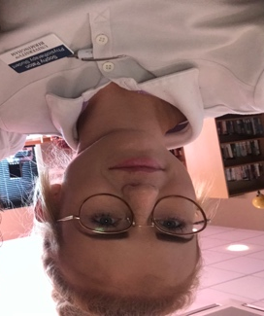

Professional Profile

PERSONAL information

Name | Sophy Paton
Position | Physiotherapy Assistant
Address | Sandford House, 6-7 Lower High Street, Stourbridge, DY8 1TE
Email / Telephone | enquiries@nppneurogroup.com | 0800 917 3330

PROFILE

Sophy is a physiotherapy assistant as well as third year BSc Physiotherapy student from the University of Birmingham, she is qualified in sports massage and taping. Sophy has completed five placements totalling 24 weeks practice and has found neurological conditions the most interesting. Sophy is looking to forward her career into neurology once she has gained more experience.

kEY sKILLS

Sophy is a keen sports player, playing both netball and football at county level, however, now only plays football for her local premier league team. She understands the importance of working within a team to achieve a successful outcome.

Sophy has experience in teaching football skills and also basic life support at University of Birmingham as well as being a sports ambassador for 5 years at her high school. Her leadership and feedback skills have developed as a result of these important roles.

Also, Sophy has achieved both her bronze and sliver Duke of Edinburgh awards, helping her to develop her problem solving and determination skills.

education

- University of Birmingham - BSc Sport Physiotherapy (Present)
- ITEC Level 3 Diploma in Sports Massage (Merit)
- Taping and strapping course (ProActive training)
- Heart of Worcester College – Extended diploma in Sports and Exercise science (D*D*D*)
- Colmers High School – 11 GCSE’s (A*-B)

